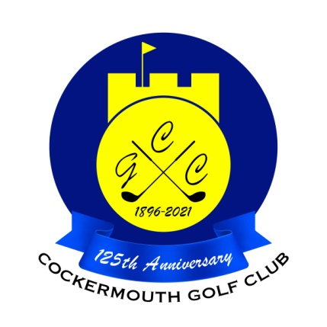
RESULT OF GOLF WEEK TEXAS SCRAMBLE
Sat 29th May 2021

Winners: T Smith & S Sowerby 68 - 10.3 = 57.7 nett

Runners Up: A Bird & A Hazlewood 65 - 5.8 = 59.2 nett

Best Ladies/Mixed

A Donohoe & M Bird 77 - 11.7 = 65.3 nett

Other Scores:

J Eland & E Pattinson 65 - 5.4 = 59.6 nett b6
S Beare & R Clubley 67 - 7.4 = 59.6 nett
T Williamson & G Simpson 62 - 0.9 = 61.1 nett b9
D Moffat & L Meddings 71 - 9.9 = 61.1 nett

