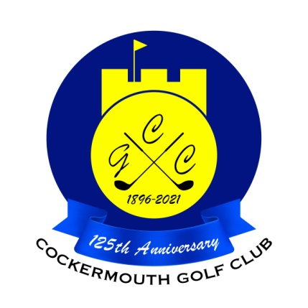
RESULT OF GOLF WEEK 4BBB
Sun 30th May 2021

Winners: G Bartle & N Fleming 47 pts

Runners Up: M Laidlow & N Laidlow 46 pts

Other Scores:
J Taylor & J Armour 45 pts
A Holliday & J Jackson 44pts
E Pattinson & S Sowerby 43 pts
S Sanderson & R Donohoe 43 pts
M Wilson & M Stewardson 43 pts
J Eland & T Smith 43 pts
D Bragg & A Andrews 43 pts
G MacDonald & A Williamson 43 pts
C Thompson & G Simpson 43 pts

Two's A Holliday 15th, A Andrews 17th, G Simpson (snr) 4th
C Thompson 4th, D Magean 17th

Each 2 worth £ 16

