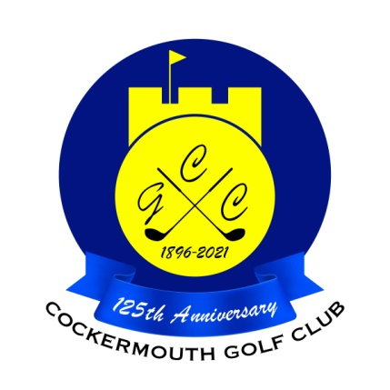
RESULT OF GOLF WEEK FOURSOMES
Sun 30th May 2021

Winners: Christine Brown & Sandra Boyes 66 nett

Runners Up: Lady Captain & Wendy Sanders 67 nett

Other Scores:

Pat Wimpress & Cath Taylor 70.5 nett
Alison Graham & Margaret Bird 72 nett
Karen Skilbeck & Elsie Huddart 72.5 nett
Margaret Wood & Doreen Mattinson 72.5 nett

Two's
Margaret Wood & Doreen Mattinson 9th & 17th Pat Wimpress & Cath Taylor 9th

Each 2 worth £10

