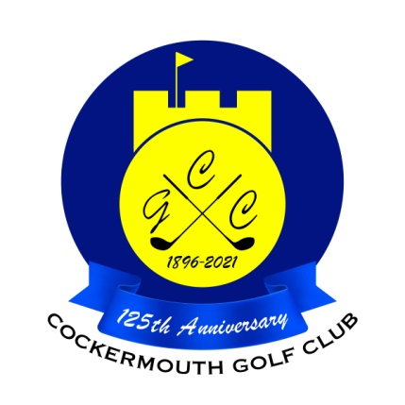
RESULT OF 4BBB STABLEFORD
Sun 2nd Jan 2022

Winners: D Heron & R Houghton 47 pts (Back 9 26)
(£15 Voucher each)

Runners Up: G Bartle & P Cliff 47 pts (Back 9 24)
(£10 Voucher each)

Other Scores:
JS Sanderson & N McGreevy 45 pts
D Magean & J Weldon 44pts
M Newton & P Hardingham 43 pts
P Newton & A Semple 43 pts

Two's P Cliff 17th
J Weldon 17th
P Newton 15th & 17th

Each 2 worth £ 11

