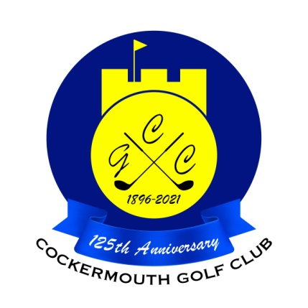
RESULT OF TEXAS SCRAMBLE
Sun 27th Feb 2022

Winners: A Andrews & D Bragg 63 - 3 = 60 nett
(£30 voucher )

Second: D Atherton & G Hannah 70 - 9.9 = 60.1 nett
b6 19.7
(£20 voucher )

Third: P Casson & M Casson 64 - 3.9 = 60.1 nett
b6 20.7
(£10 voucher)

Other Scores:

M Laidlow & N Laidlow 64 - 3.3 = 60.7 nett
T Williamson & A Williamson 65 - 3.3 = 61.7 nett

