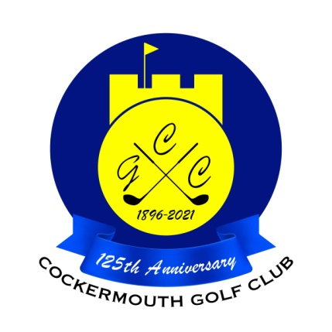
QUALIFIERS FOR CAPTAIN'S PRIZE
24th April 2022

N Fleming 75 - 11 = 64 Nett
D Burns 80 - 13 = 67 Nett
A Berry 87 - 18 = 69 Nett
J Jackson 84 - 15 = 69 Nett
N Laidlow 79 - 9 = 70 Nett
D Heron 88 - 17 = 71 Nett
A Smith 78 - 7 = 71 Nett
D Bragg 76 - 5 = 71 Nett
P Graffin 77 - 5 = 72 Nett
Peter Brown 81 - 9 = 72 Nett
K Bell 84 - 12 = 72 Nett P Esposito 94 - 22 = 72 Nett
A Williamson 79 - 7 = 72 Nett
A Andrews 79 - 6 = 73 Nett
M Wilson 75 - 2 = 73 Nett
H Harrington 97 - 24 = 73 Nett (cpo)

Two's A Andrews 9th K Bell 9th
N McGreevy 9th R Houghton 9th
M Wilson 9th

Each 2 worth £18

