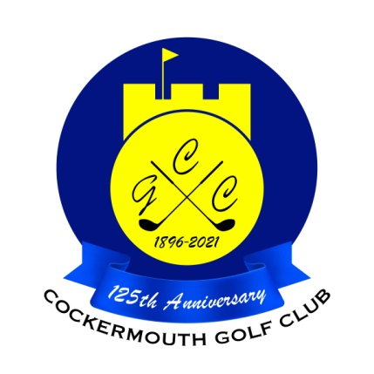
RESULT OF EASTER 4BBB
15th April 2022

Winners: C Gorley & M Gorley 51pts

Runner Up: W Varty & L Cooke 48pts

Other scores:
J Dixon & M Dixon 47Pts
P Graffin & G Simpson (snr) 47 Pts
L Skillen & D Burns 46 Pts
D Lake & D Daley 46 Pts

Two's:
M Laidlow 15th P Newton 9th
B Denham 9th A Andrews 9th
P Graffin 9th D Burns 9th
B Thompson 9th A Cowan 9th & 15th
A Semple 15th M Graham 9th

Each 2 worth £8

