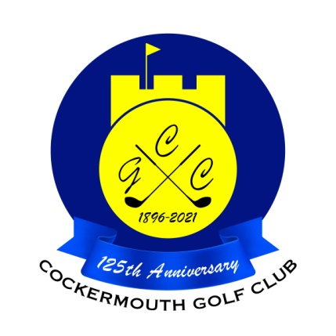
RESULT OF EASTER MIXED GREENSOME
16th April 2022

Winners:
D Skilbeck & M Bird 79 - 15 = 64 nett (cpo)

Other scores:
A Taylor & J Smith 81 - 17 = 64 nett
G Bartle & E Huddart 90 - 25 = 65 nett
G Macdonald & C Taylor 85 - 20 = 65 nett
P Risino & A Milburn 87 - 20 = 67 nett
N Laidlow & P Wimpress 87 - 20 = 67 nett

Two's:
D Skilbeck & M Bird 10th

Each 2 worth £22 (£11 each)

(8 Teams in Total)

