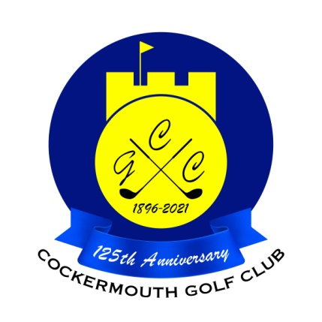
RESULT OF THE SCRATCH MATCHPLAY QUALIFIER
3rd April 2022

Qualifiers:
B Denham 70 Gross
R Kirk 71 Gross
D Bragg 72 Gross
G Simpson (jnr) 73 Gross
A Andrews 73 Gross
G Simpson (snr) 74 Gross
D Watson 74 Gross
M Wilson 75 Gross
R Williamson 76 Gross
T Williamson 76 Gross
A Williamson 76 Gross
D Thurlow 77 Gross
P Graffin 77 Gross
M Reid (snr) 77 Gross
B Kirk 78 Gross
D Johnstone 78 Gross)

