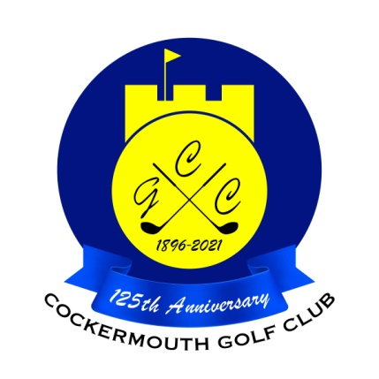
RESULT OF GOLF WEEK 4BBB STABLEFORD
Sun 29th May 2022

Winners: A Hazlewood & A Bird 47 pts

Runners Up: D Heron& P Mifsud 45 pts (cpo)

Other Scores:
M Casson & C Weir 45 pts
A Blackburn & A McGuirk 44pts
M McKenna & P Martin 44 pts
B Thompson & W Varty 44 pts
G Hunter & D Winder 44 pts

Two's B Denham 2nd
W Varty 10th
Peter Brown 9th
A Bird 9th
C MaCleod 9th

Each 2 worth £ 16

