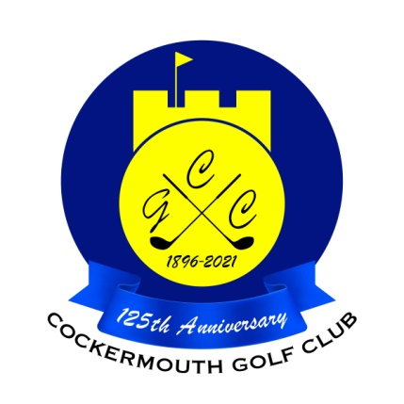
RESULTS OF GOLF WEEK MIXED DOUBLE GREENSOME
31st May 2022

Winners: A Taylor & E Huddart 62 Nett

Other scores:
A Semple & J Hadfield 63 Nett (b9)
R Mumberson & A Milburn 63 Nett (b9)
D Skilbeck & C Taylor 63 Nett

Two's:

A Taylor & E Huddart 15th

Each 2 worth £16 (£8 each)

