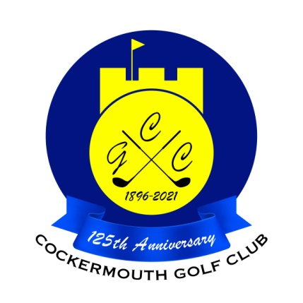
QUALIFIERS FOR HERBERT JACKSON
22nd May 2022

N Laidlow 73 - 8 = 65 Nett
G MacDonald 81 - 13 = 68 Nett
Peter Brown 76 - 8 = 68 Nett
M Cason 77 - 8 = 69 Nett
P Esposito 90 - 21 = 69 Nett
D Daley 83 - 13 = 70 Nett
C Macleod 80 - 10 = 70 Nett
P Martin 84 - 14 = 70 Nett
P Mifsud 94 - 23 = 71 Nett
M McKenna 88 - 17 = 71 Nett
N Fleming 81 - 10 = 71 Nett P McDonald 82 - 10 = 72 Nett
M Wilson 74 - 2 = 72 Nett
S Sanderson 87 - 15 = 72 Nett
A Andrews 78 - 6 = 72 Nett
M Stewardson 81 - 8 = 73 Nett

As leading qualifier, N Laidlow wins the Pickett Howe Trophy

Two's N Laidlow 9th
A Andrews 4th & 10th

Each 2 worth £16

