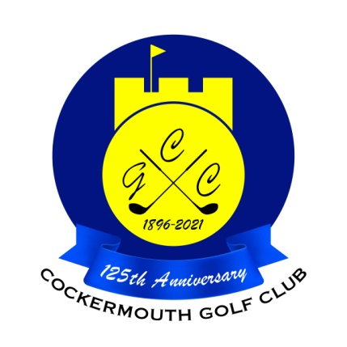
RESULT OF MARRIED BLISS GREENSOME
7th May 2022

Winners: C Taylor & A Taylor 79 - 16 = 63 nett

Other Scores K Skilbeck & D Skilbeck 89 - 25 = 64 nett
V McGreevy & N McGreevy 86 - 21 = 65 nett
A Donohoe & R Donohoe 83 - 18 = 65 nett

Unmarried section:

Winners: C Sykes & R Frew 83 - 16 = 67 nett

Other scores J Hadfield & G MacDonald 83 - 16 = 67 nett
P Wimpress & F Risino 93 - 25 = 68 nett
L Mumberson & R Mumberson 91 - 23 = 68 nett

Two's S Boyes & M Casson 4th
C Taylor & A Taylor 17th

Each 2 worth £20

