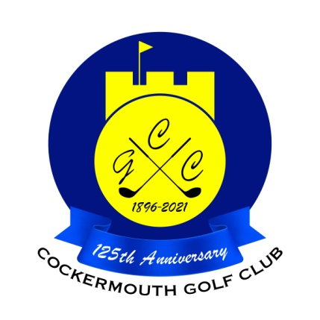
RESULT OF MENS FOURSOMES QUALIFIER
15th May 2022

Qualifiers:

M Reid (snr) & M Reid (jnr) 61.0 Nett
D Atherton & A Jones 64.5 Nett
K Bragg & C Heron 64.5 Nett
A Andrews & D Bragg 65.5 Nett
M Graham & E Law 66.0 Nett
M Newton & P Hardingham 66.5 Nett
I Carruthers & D Skilbeck 67.0 Nett
D McDonald & A Ireland 67.0 Nett

