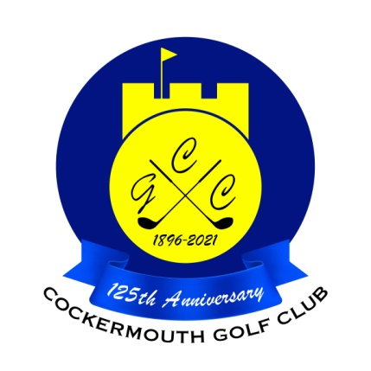
RESULT OF GOLF WEEK LADIES FOURSOMES
Sun 29th May 2022

Winners: M Bird & P Wimpress 64 nett

Runners Up: E Wilson & E McElhinney 67 nett

RESULT OF GOLF WEEK LADIES STABLEFORD
Wed 1st June 2022

Winner: J Hadfield 42 pts

Runner Up: J Alcock 41 pts

Two's J Smith 9th
D Jackman 9th

Each 2 worth £ 19

