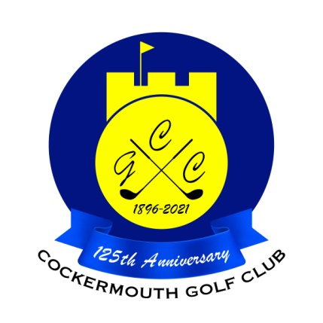
RESULT OF GOLF WEEK 4BBB STABLEFORD
Sun 28th May 2023

Winners: S Shaw & S Sanderson 43 pts

Runners Up: D Daley & D Lake 41 pts (cpo)

Other Scores:
M Casson & P Casson 41 pts
C Thompson & G Simpson (Snr) 41 pts
K Bell & P Brown 39 pts
M Laidlow & N Laidlow 39 pts

Two's C Thompson 5th
A Cowan 9th
A Murray 4th
N McGreevy 9th
N Fleming 9th
G Bartle 9th

Each 2 worth £ 9

