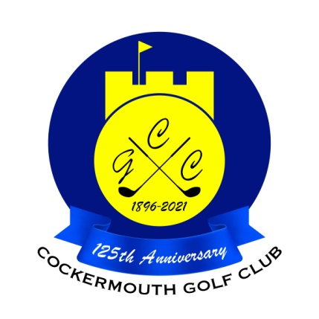
RESULTS OF GOLF WEEK MIXED DOUBLE GREENSOME
30th May 2023

Winners: R Mumberson & C Taylor 63 Nett

Other scores:
A Taylor & L Mumberson 66 Nett
R Donohoe & E Huddart 66 Nett
N Fleming & J Smith 67 Nett

Two's:

S Sanderson & A Donohoe 17th

Each 2 worth £16 (£8 each)

