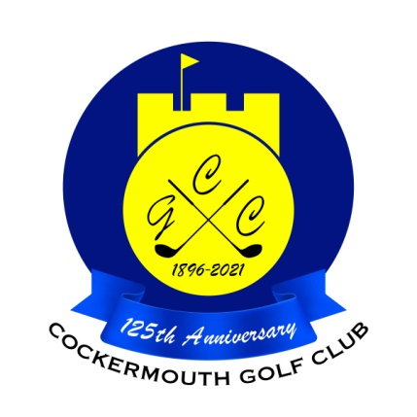
QUALIFIERS FOR HERBERT JACKSON
21st May 2023
G Quinn 84 - 24 = 60 Nett
D Daley 76 - 14 = 62 Nett
C Thompson 72 - 9 = 63 Nett
P McDonald 73 - 10 = 63 Nett
F Risino 80 - 16 = 64 Nett
Dec McDonald 85 - 21 = 64 Nett
D Thurlow 75 - 11 = 64 Nett
C Gorley 77 - 12 = 65 Nett
D Johnstone 71 - 6 = 65 Nett
P Vaughan 82 - 17 = 65 Nett
D Heron 80 - 15 = 65 Nett A Holliday 71 - 5 = 66 Nett
G Hannah 89 - 23 = 66 Nett
N Stewart 81 - 13 = 68 Nett
D Lake 80 - 12 = 68 Nett
M Laidlow 75 - 7 = 68 Nett

As leading qualifier, G Quinn wins the Pickett Howe Trophy
As Runner Up, David Daley wins a voucher for £10

Two's D Bragg 9th N McFadyen 1st A Taylor 17th
K Ruddy 4th D Heron 17th P Vaughan 9th

Each 2 worth £11

