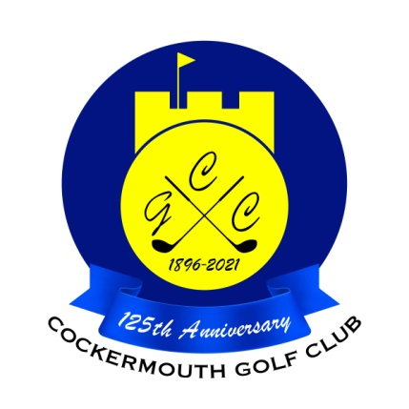
RESULT OF MENS FOURSOMES QUALIFIER
14th May 2023

Qualifiers:

P Casson & D McDonald 61 Nett
(£15 voucher each)
D Skilbeck & I Carruthers 64 Nett
N Stewart & S Shaw 66 Nett
A Murray & F Manchon 66 Nett
T Williamson & A Williamson 66 Nett
D Heron & C Heron 68 Nett
G Bartle & N Fleming 70 Nett
C Gorley & E law 70 Nett

Two’s:
C Gorley & E Law 17th
D Skilbeck & I Carruthers 17th
S Hodgson & S Sullivan 4th

Each 2 worth £18 each

