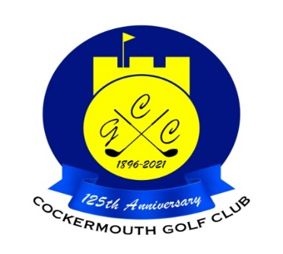

JOHN PEEL SHIELD
2023

WINNER: K Curwen 82-18=64 nett
DIV 1 WINNER: K Watson 75-7=68 nett cpo

Other Scores:
Div 1 P Graffin 73-5=68 nett cpo
D Twelvetree 78-10=68 nett cpo
A Bailiff 79-11=68 nett cpo

Div 2 G MacDonald 82-15=67 nett
S Shaw 84-17=67 nett

Two's

M Laidlow 4th&17th

Each 2 worth £29

