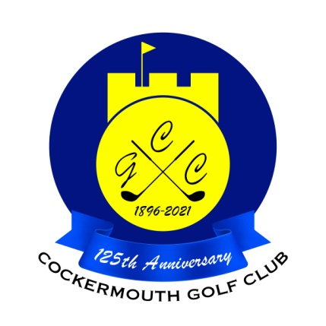
RESULT OF DAILY MAIL FOURSOMES
16th September 2023

Winners:
G Simpson (jnr) & Dec McDonald 69 nett (b9 37.5)

Other scores:
M Casson & R Frew 69 nett (b9 38)
N Laidlow & M Laidlow 69 nett (b9 38.5)
S Cusack & D Jones 71 nett
G Simpson (snr) & C Thompson 72 nett

Two's G Simpson (jnr) & Dec McDonald 9th
G Simpson (snr) & C Thompson 17th
S Cusack & D Jones 9th
N Laidlow & M Laidlow 9th

Each 2 worth £ 7 (£3.50 each)

