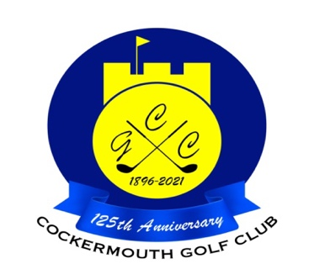

**Turkey Competition 12 Nov 2023**

**Overall Result**

**MEN’S WINNER: Niall McGreevey 46 pts**

**LADIES WINNER: Janet Smith 38 pts**

**£25 Voucher each**

**Other Scores: Colin Weir 43 pts**

**Mark Newton 42 ts**

**Grahame Hannah 41 pts**

**Olivia Harrison 37 pts**

**2’s:**



**Each 2 worth £7**