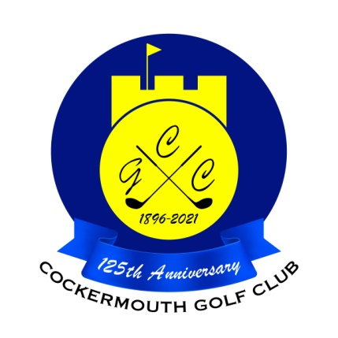
RESULT OF EASTER MIXED GREENSOME
30th March 2024

Winners:
G Bartle & M Bird 85 - 21 = 64 nett

Other scores:
P Humphreys & Lady Captain 88 - 23 = 65 nett
M Casson & C Taylor 84 - 18 = 66 nett
D Magean & J Eastwood 98 - 29 = 69 nett
Mr President & P Airey 88 - 19 = 69 nett
D McDonald & O Harrison 85 –15 = 70 nett

Two's: G Bartle & M Bird 9th

Each 2 worth £29

