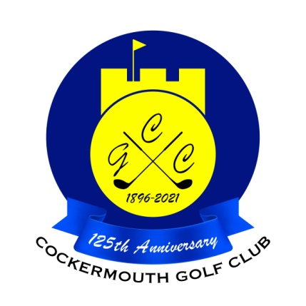
RESULT OF THE SCRATCH MATCHPLAY QUALIFIER
21st April 2024

Qualifiers:
T Williamson 67 Gross
I McDowell 69 Gross
N Varty 69 Gross
P Graffin 69 Gross
A Andrews 69 Gross
D Bragg 70 Gross
G Simpson (jnr) 70 Gross
M Laidlow 73 Gross
A Skillen 74 Gross
G Simpson (snr) 75 Gross
A Taylor 76 Gross
A Williamson 76 Gross
S Shaw 77 Gross
R Carruthers 78 Gross
R Frew 78 Gross
N Laidlow 78 Gross

