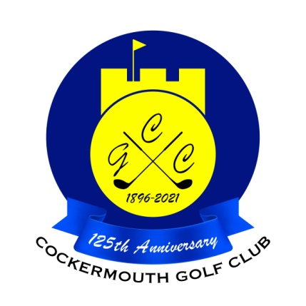
QUALIFIERS FOR HERBERT JACKSON
5th May 2024
Dec McDonald 63 Nett
M Newton 64 Nett
P Dawson 64 Nett
A Skillen 65 Nett
J Broomfield 66 Nett
K Bell 66 Nett
P Horsley 66 Nett
M Laidlow 67 Nett
M Bell 68 Nett
N Fleming 68 Nett
R Houghton 68 Nett D Johnstone 68 Nett
D Heron 68 Nett
P Graffin 68 Nett
D Semple 68 Nett
M Wilson 68 Nett

As leading qualifier, Dec McDonald wins the Pickett Howe Trophy
Division 2 Winner is M Newton

Two's A Andrews 17th K Watson 9th D Twelvetree 17th
N Fleming 17th G MacDonald 9th

Each 2 worth £15

